Java Course

From [Mosh](https://youtu.be/eIrMbAQSU34?si=xYg9MVn2gTwQJ3s8)

JDK comprise java compiler, java runtime environment (JRE) and more,

Java has 4 editions:

1. Java EE (Enterprise Edition; spring, distributed systems, fault tolerance systems etc.)
2. Java SE (Standard Edition; normal)
3. Java ME (Micro Edition; mobile code)
4. Java Card (for Smart Cards like banking cards etc)

# Flow

## Java underhood

Java undergoes 2 steps

1. Compilation: java compiler (comes with jdk) compiles the code (*.java) to byte code (*.class)
2. Execution: java runtime environment (jre) has jvm which converts byte code to native code

## Running with CMD

Use javac command for step 1 then java command for step 2

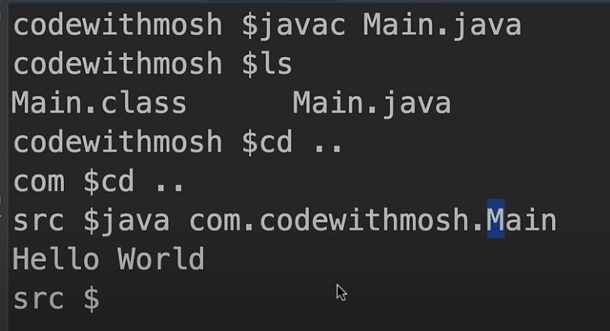

## Data Types

2 types

1. Primitive: stores values, has fix length in memory (like int)

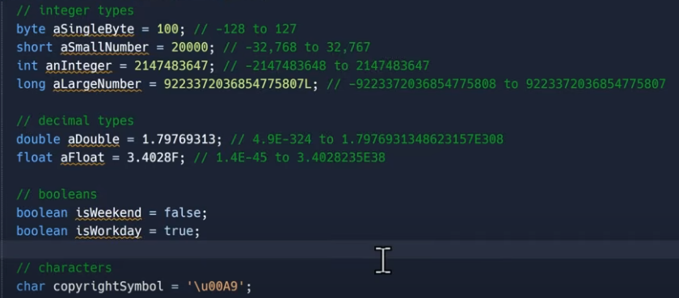

1. Non-primitive (reference): stores reference, has variable length in memory
   1. Strings (unlike ts but same as c#)
   2. Class
   3. Arrays

## Implicit and Explicit type conversion

Implicit happens when from smaller to larger data type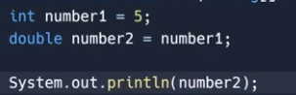

Explicit happens from larger to smaller data type (compiler needs to be told explicitly)

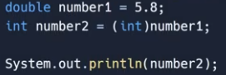

## String

String data type is combination of multiple char data type

Char is in single quotes and string is in double quotes

== compares the memory references so if string a =”2” and string b = “2” then jvm assigns a to b because its value is same

Some methods:

**Format:**

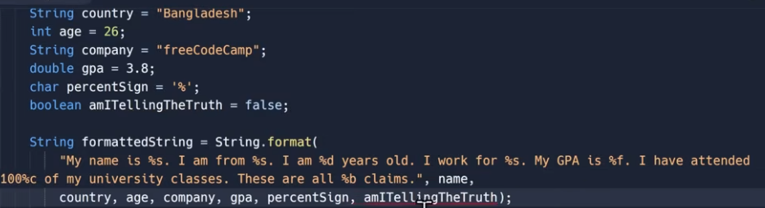

**Lenths, isEmty, equals, equalsIgnoreCase, replace, contains**

## Arrays

Can be declared like this

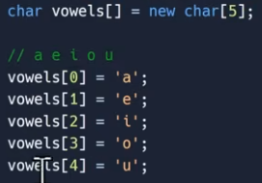

## ArrayList

It has no fixed length and can be modified, where as regular array has fixed length

## Hashmap

Key value pairs

# Java OOP

New keyword is used to create an object from class